STRAIGHT NO CHASER ANNOUNCE ADDITIONAL “ONE SHOT TOUR” LIVE DATES
BELOVED A CAPPELLA GROUP EXTENDS TOUR IN SUPPORT OF SEVENTH STUDIO ALBUM “ONE SHOT”

“…an entertaining walk down memory lane that feels fresh and exciting…One Shot showcases the band’s amazing versatility, creativity and musical precision.” – PARADE

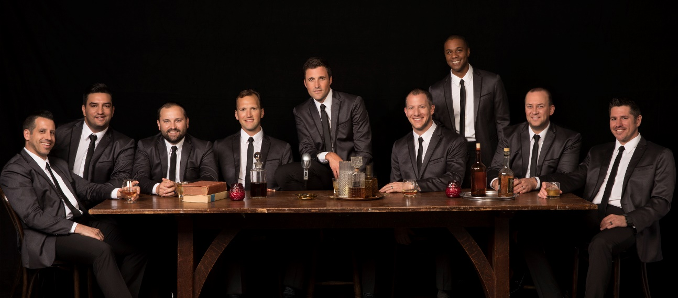
download hi-res here; credit: Jimmy Fontaine

Award-winning, internationally acclaimed Atlantic Records a cappella group Straight No Chaser has today announced a new string of East Coast and Midwest shows added to their North American “One Shot Tour.” After closing 2018 with nearly five months of touring in support of their seventh studio album One Shot, the guys are back on the road this spring for another run of live performances. The dates kick off on April 23rd at Columbia, MO’s Jesse Auditorium and culminate on May 5th at the venerable Providence Performing Arts Center in Providence, RI (full itinerary below).

Pre-sale tickets will be available to members of Straight No Chaser’s official fan club beginning Tuesday, January 22nd; all remaining tickets will go on sale to the general public on Friday, January 25th. For complete ticket information and other news, please see www.sncmusic.com/tour.

Released in November, One Shot features 16 genre-spanning new songs alongside twelve entertaining conversational interludes wherein the nine members of Straight No Chaser trace their unlikely rise from an undergraduate singing group at Indiana University to a beloved Atlantic Records act with a devoted international fanbase. Along with “Motownphilly/This Is How We Do It,” the LP sees SNC doing what they do best with distinctive takes on classic pop and soul favorites, including Ricky Martin’s “Livin’ La Vida Loca,” Fleetwood Mac’s “Go Your Own Way,” James Brown’s “Papa’s Got a Brand New Bag,” and Percy Sledge’s “When a Man Loves a Woman.” “One Shot” is perhaps highlighted by a richly harmonized version of Simon & Garfunkel’s “Homeward Bound” in which the hard-touring group expresses their deep yearning for the comforts of family life. The touching companion visual shows footage of the group on tour mixed with some personal home videos of their families. The video had its premiere via USA Today.

The album’s release coincided with the 10th Anniversary of Straight No Chaser signing with Atlantic Records and the release of their RIAA gold certified debut album, “Holiday Spirits” after a video of the group performing “12 Days of Christmas” went viral on YouTube and became the most viewed video of 2007. Upon the release of “Holiday Spirits” in 2008, The New York Times predicted “this may be the year’s most unlikely major label story.” Now, more than ten years later with seven full length albums and four EPs under their belt, over 100 million YouTube views to date and over 1.6 million albums sold in the US alone, they will again hit the road to celebrate and invite fans to join them on the “One Shot Tour.”

For complete information and ticket availability, please see www.sncmusic.com/tour.

CONNECT WITH STRAIGHT NO CHASER:
SNCMUSIC.COM
FACEBOOK
TWITTER
YOUTUBE

STRAIGHT NO CHASER 2019 TOUR DATES

APRIL
23 Columbia, MO Jesse Auditorium
24 Joliet, IL Rialto Theater
25 Muncie, IN Emens Auditorium
26 Niagara Falls, ON Fallsview Casino Resort
27 Niagara Falls, ON Fallsview Casino Resort
28 Oxon Hill, MD MGM National Harbor Casino
30 Greenville, SC Peace Center

MAY
2 Huntington, NY Paramount Theatre
3 Shippensburg, PA Luhrs Center
4 Lancaster, PA American Music Theatre
5 Providence, RI Providence Performing Arts Center

