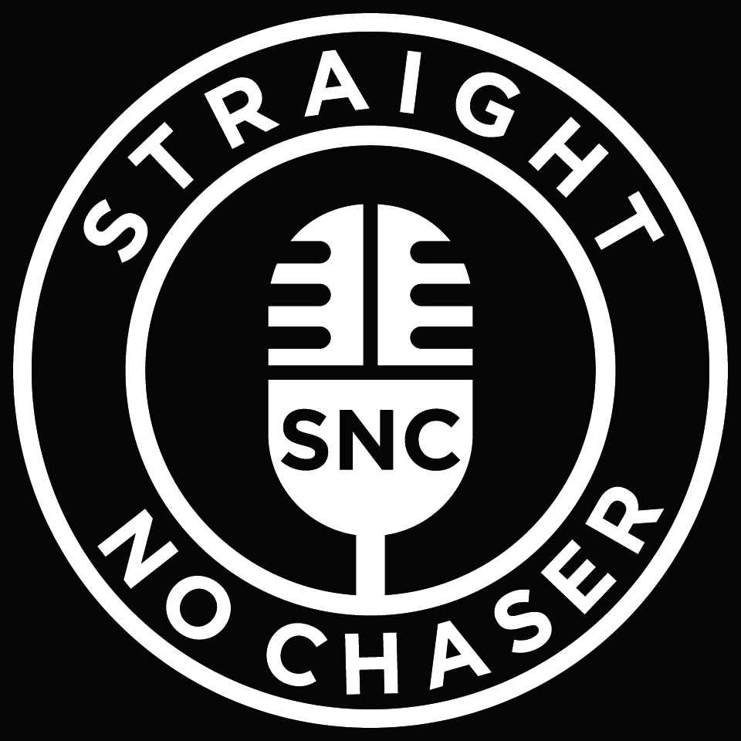

Straight No Chaser has had an amazing decade. Ten years after turning a collegiate hobby into a recording career that has taken them around the world on tour, the a cappella group tells its story through music on ONE SHOT.

Their seventh LP features 16 genre-spanning songs, and 10 entertaining conversational interludes, as the members of Straight No Chaser trace their unlikely rise from an undergraduate singing group at Indiana University to a beloved Atlantic Records act with a devoted international fanbase. Along the way, Straight No Chaser has sold more than 1.6 million albums in the U.S. and amassed more than 100 million YouTube views thanks to tightly arranged songs, impeccable vocal harmonies, and a healthy sense of humor. Yet Straight No Chaser’s success was never a given—these singers have worked hard to make the most of an unexpected opportunity when they signed with Atlantic and released their first album, HOLIDAY SPIRITS, in 2008.

Recorded mostly in Bloomington, Indiana, with producer Steve Lunt, the track list for ONE SHOT reflects that sense of now or never, starting with opener and first single “Motownphilly/This Is How We Do It,” an energetic mash-up of Boyz II Men and Montell Jordan. Straight No Chaser made Jordan’s “This Is How We Do It” a staple of its repertoire in collage. Adding “Motownphilly,” with its lyrics about chasing improbable success, captured the way the singers felt as undergrads. “The lyrics from the Boyz II Men song fit our experience: We dreamed about this and now we are doing it, performing all over the world,” says Randy Stine, an original member.

It took a few years. After the founding members of Straight No Chaser graduated in 1999, they got jobs, found love, and made lives for themselves as new undergrads replaced them in the group on campus. In 2006, Stine posted a clip on YouTube of Straight No Chaser singing “The 12 Days of Christmas” at a 1998 performance, and it went viral. Atlantic Records Chairman & CEO Craig Kallman saw it and contacted the guys to see if they would be interested in reuniting to make an album. It wasn’t necessarily an easy decision. “It was scary to jump into because we were giving up life as we knew it,” Stine says. “I envisioned it as a boat leaving the pier,” he says. “Either you're going to jump on and make the boat or you're not. And I thought, ‘Even if the boat sinks and I have to swim back to shore, so be it.’”

Far from sinking, the group has only picked up speed on the way to making ONE SHOT. “Every year it gets better and better,” says Tyler Trepp. “We keep surprising ourselves in a good way, and it just keeps growing.” Along with Stine and Trepp, the current lineup features Walter Chase, Jerome Collins, Seggie Isho, Michael Luginbill, Charlie Mechling, Steve Morgan, and David Roberts. They all have a hand in choosing songs, which mirror the singers’ widespread musical tastes, ranging from R&B and old-school funk to folk and classic rock. In addition to “Motownphilly/This Is How We Do It,” the group tackles Ricky Martin’s “Livin La Vida Loca,” Fleetwood Mac’s “Go Your Own Way,” James Brown’s “Papa’s Got a Brand New Bag,” and Percy Sledge’s “When a Man Loves a Woman,” a soulful ode to the singers’ significant others.

There’s also a take on Loverboy’s “Working for the Weekend,” Johnny Cash’s version of “I’ve Been Everywhere,” and a yearning for the comforts of family life on a richly harmonized version of Simon & Garfunkel’s “Homeward Bound.” “We all rallied around that song because it really spoke to life on tour,” Stine says. “We are loving what we're doing, but there's always a bit of you that's missing home. Especially with all of us being parents now, it's that much tougher when you leave.”

So much of what Straight No Chaser has done over the past 10 years is the stuff of dreams: They’ve collaborated with Paul McCartney, Stevie Wonder, Elton John and Dolly Parton, to name a few. They’ve performed on national TV early in the morning, on Today; and long after dark, on Late Night with Jimmy Fallon. They’ve toured North America, Europe, and Australia, and consistently rank among Pollstar’s top 100 touring acts in North America. “We literally have to pinch ourselves every day that this actually happened,” Collins says. “Now we’re 10 years still in the game, and we’re still a successful act. We started this just for fun and now we’re doing it as a career.”

They have no intention of stopping—it’s just too much fun. “We’re going to ride this train,” Trepp says. “Each tour is something new, and we’re always surprised at the things we get to do.”

###

